* Draft script including:
  + the main character and their interactions
    - The player has interactions with destructible walls/fences & the items that they need to progress.
  + Background stories
    - You the player decided to explore an abandoned theme park, but once you entered a maze at the theme park, the entrance disappeared behind you, so now you need to find the way out.
  + Level and mission stories
    - You need to find an item in the maze section that you currently are in, to be able to progress to the next section.
* Character and narrative dialogue
  + There is no character dialogue.
  + Narrative text will only be at the start & end of the game.
* Storyboards visually presenting events in the story

|  |  |
| --- | --- |
| Storyboard Key | |
| The breakable fence/wall |  |
| Player |  |
| Item needed to progress section/area |  |

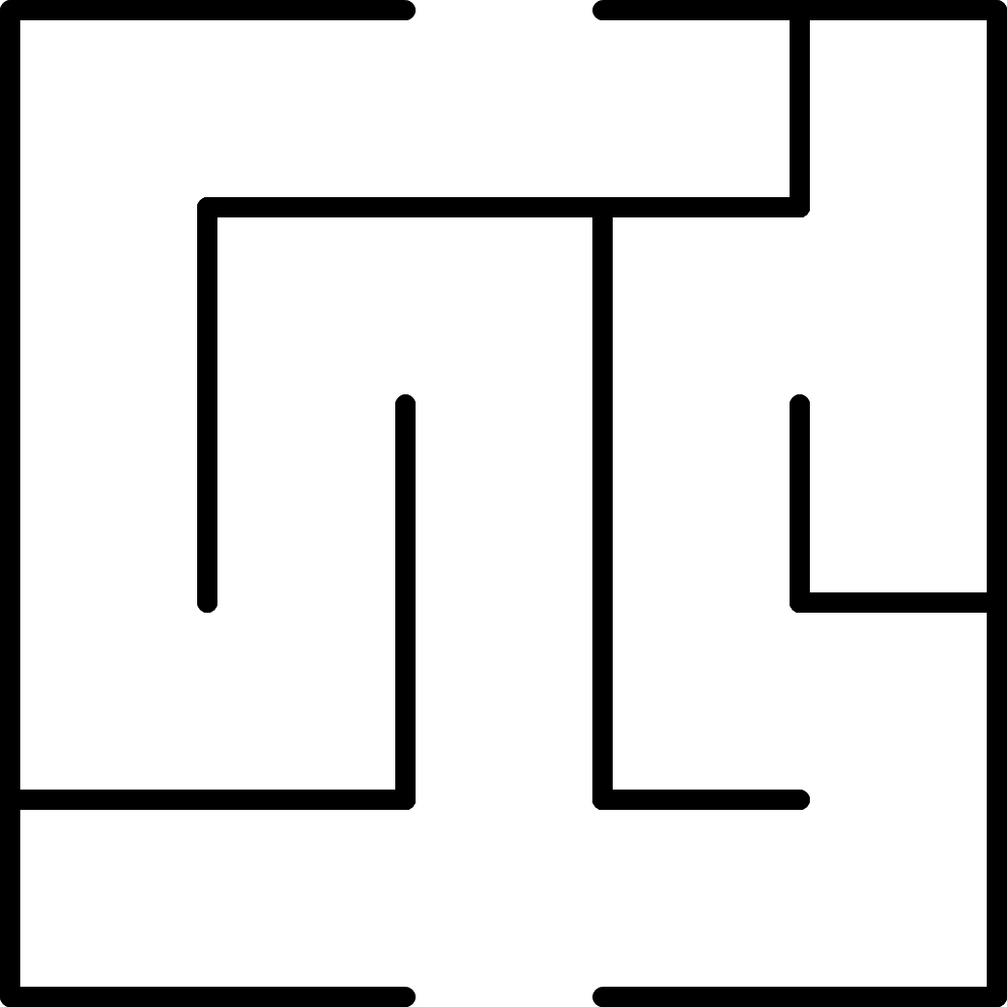

Once this fence/wall is destroyed & passed through you will get the victory screen

After collecting this item, you will be able to interact with the 2nd destructible fence/wall

After collecting this item, you will be able to interact with the 1st destructible fence/wall

The player starts & sees text telling what the controls & the objective are.